Chignal Parish Council
C/O 45 Cherry Garden Road, Great Waltham, Chelmsford, Essex, CM3 1DH
Tel: 01245 360811 Email: Clerk@Chignal-pc.gov.uk
Clerk: Will Adshead-Grant Chair: Lynn Ballard
Website: Chignal-pc.gov.uk Vice Chair: Linda Nelson
Posted: 02.09.2026
You are hereby summonsed to attend the Bi-Monthly Meeting of the Chignal Parish Council on Monday 14th September 2026 at 7.30pm for transacting the following business.
w j adshead-grant, Clerk.

The Public and Press are cordially invited to be present. Members of the public are invited to address the Council at the Public Open Session.

2026/1055 Chair’s Welcome.

2026/1056 Apologies for Absence.

2026/1057 Declarations of Interests and any requests for dispensation.

2026/1058 Public Open Session for any matters that need to be drawn to the Parish Council’s attention. (The item does not need to be on the current agenda).

2026/1059 Confirmation of the minutes of the Ordinary meetings of the Parish Council held on 13th July 2026.

2026/1060 Note the Orchard Committee note minutes of the 2nd September.

2026/1061 County and City Councillors’ Reports.

2026/1062 Planning.
- Chelmsford Local Plan: The Plan is subject to an Independent Examination conducted by a Planning Inspector appointed by the Secretary of State. The issues to be examined have not yet been published.
- Norwich to Tilbury Development Consent Order Examination
Update on representations made by the NW/SW of Chelmsford Parishes.
The DCO Examination closed on 10 August. The Planning Inspectorate has three months to prepare a report and recommendation for the Secretary of State for Energy Security and Net Zero, who will decide whether to grant consent for the project. The decision is expected within three months of the recommendation being received.

2026/1063 Planning decision by Chelmsford City Council.
To note the following tracked application and their status:

Reference | Address | Status
18/00001/MAS | Land North Of Warren House Roxwell Road Writtle Chelmsford Essex | Pending Decision
26/00639/FUL | New House The Green Chignal St James Chelmsford Essex CM1 4TY | Pending Consideration
26/00300/FUL | 2 Kilnfield Barns Chignal Road Chignal Smealy Chelmsford Essex CM1 4GR | Application Permitted
26/00749/FUL | Barn South Hillcroft Chignal Road Chignal Smealy Chelmsford Essex | Pending Consideration
21/01545/OUT | Land North Of Warren House Roxwell Road Writtle Chelmsford Essex | Pending Decision
2026/1064 Planning Applications.
1. Planning Application Reference: 26/00639/FUL. Address: New House, The Green, Chignal St James, Chelmsford. Description of works: Retention of raised terrace to rear of house together with provision of a new brick boundary wall and brick planters
Click to View - https://publicaccess.chelmsford.gov.uk/online-applications/applicationDetails.do?activeTab=summary&keyVal=TF2W7FBRHHK00
Approve Parish Council comments on an amended application.

2026/1065 Planning Breaches:

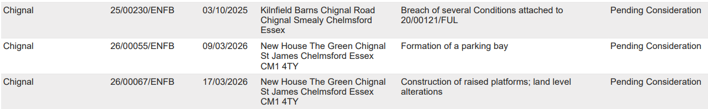

2026/1066 Update on the accounts 2026/2027.

 | Budget |  | Current Spend |  | Balance | Spent
Staff Cost | £5,600 |  | £1,794 |  | £3,806
Admin | £4,260 |  | £1,271 |  | £2,989
Total | £9,860 |  | £3,065 |  | £6,795 | 31%
Cil | £9,902 |  | £1,167 |  | £8,735
Reserves | £16,441 |  | £184 |  | £16,257
Orchard | £2,122 |  | £272 |  | £1,850

2026/1067 Finance.
Accounts taken 30.08.2026 19:36

Cheque Account £ 406.03 (0% interest)
Savings Account £ 33,745.51 (1.05% interest)

Total £ 34,151.54

Reserves
Orchard | £1,849
General Reserve | £16,256
Cils | £8,834

2026/1068 Payments for approval.
To approve the following payments:
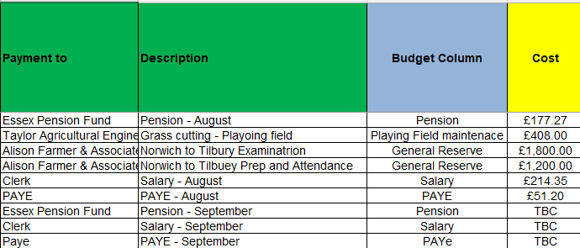

Total for approval £ 3,850.82

2026/1069 Review of the Bi-monthly bank reconciliation

2026/1070 Chelmsford Association of Local Councils, (CALC).
Attendance at the AGM on Weds, 21st October at 6.30pm, South Hanningfield Village Hall.

2026/1071 Chignal Community Meeting.
Consider possible workshop topics and meeting date.

2026/1072 Setting the Budget and Precept for 2027/28:
Agree Budget committee meeting date.

2026/1073 Representatives’ Reports: to discuss and debate any items.
- Little Hollows / Copperfield Place Liaison - Cllr Elwick
- Landscaping – Update on replacing dead trees and hedging.

- Playing Field - Cllr Elwick, Cllr Towns and Cllr. Polley
- Litter: large amounts of bottles and cans left by the goal post and gazebo. Consider installing anti-litter sign inside the playing field.
- Car park: new padlock needed for bollard.
- Gazebo: damage to a paving slab by the entrance.
- Pétanque: progress report by the working group on construction.

- Village Hall Liaison - Cllr Towns.

- Community Engagement - Cllr Nelson and Cllr Stainton.

- Parish website: update
- Parish Christmas card: approval to print 400 copies. 2025 cost: £200.00 for design and print.

- Community Safety – Cllr Lewis.
- Defibrillators: updates on training.
- Defibrillator at Hollow Lane – Highways License application.

- Highways (include Hedges) - Cllr Towns, Cllr Elwick and Cllr Ballard
Pothole repairs: update on priority area submitted by our County Councillor

- ​Footpaths/Bridleways – Cllr Nelson, Cllr Towns and Cllr. Polley
- Footpath audit – progress report.

- Nature Recovery. – Cllr Lewis and Cllr Ballard.
- Impact of drought on young trees planted along Chignal Road.

2026/1074 Items for the next Agenda:

Next meetings:

Monday 09th November 2026 Bi-Monthly Meeting
Monday 11th January 2027 Bi-Monthly Meeting
Monday 08th March 2027 Annual Parish Meeting and Bi-Monthly Meeting
Monday 10t^{h} May 2027 Annual General Meeting and Bi-Monthly Meeting

