Posted: 03.09.2025
You are hereby summonsed to attend the Bi-Monthly Meeting of the Chignal Parish Council on Monday 8th September 2025 at 7.30pm for transacting the following business.
w j adshead-grant, Clerk.

The Public and Press are cordially invited to be present. Members of the public are invited to address the Council at the Public Open Session.

Governance

2025/899 Chair’s Welcome.

2025/900 Apologies for Absence.

2025/901 Confirmation of the minutes of the meeting of the Parish Council held on July 2025.

2025/902 Note the minutes of the Orchard Committee held on 2nd September 2025.

2025/903 Declarations of Interests and any requests for dispensation.

2025/904 Public Open Session for any matters that need to be drawn to the Parish Council’s attention. The item does not need to be on the current agenda.

2025/905 County and City Councillors’ Reports.

    - Essex County Councillor Report – Cllr Mike Steel
    - Chelmsford City Councillor Report - Cllr Nicolette Chambers

2025/906 Planning.
National Grid Electricity Transmission (NG-ET), Norwich to Tilbury: submission of the planning application 29th August and next steps www.nationalgrid.com/norwich-to-tilbury

2025/907 Planning Applications.
      - Planning Application Reference: 25/01138/FUL
Address: 3 Kilnfield Barns, Chignal Road, Chignal Smealey
Description of works: Single storey side extension.

      - Planning Application Reference: 25/01124/FUL
Address: Barn South Hillcroft, Chignal Road, Chignal Smealey
Description of works: Removal of identified buildings on site. Conversion of existing buildings on site to a residential dwelling

3. Reference: 25/01182/FUL
Address: Land Southeast of Woodhall House Chignal Road Chignal Smealy Chelmsford.
Description of works: Proposed new dwelling and garage, associated landscaping, parking and formation of access.

2025/908 Chelmsford Association of Local Councils, (CALC)
Review constitution and approval of annual membership fee of £40.00.
Response to CALC questionnaire, feedback from CALC meeting on 14 August and attendance at the CALC AGM on 15th October, 7pm at Great Baddow Parish Hall. Focus on the impact of Devolution in Essex and Local Government Reorganisation on Town and Parish Councils.

2025/909 Essex Love your Bus.
update on implementation of project to promote the Lodge bus services 17/18.

2025/910 Chignal Parish branding:
update on using the branding on parish council emails, agendas etc; parish notice boards; and community orchard information board. Siting and installation of a new parish notice board near the junction of Chignal road and Hollow Lane.

2025/911 Chignal Community Meeting
items for discussion and date in early November.

Finance

2025/912 Update on Budget 2025-2026

 | Budget |  | Current Spend |  | Balance | Remaining
Staff Cost | £5,600 |  | £2,194 |  | £3,406
Admin | £5,405 |  | £2,251 |  | £3,154
Total | £11,005 |  | £4,445 |  | £6,560 | 60%
Cil | £16,660 |  | £5,858 |  | £10,802
Reserves | £19,616 |  | £1,947 |  | £17,669
Orchard | £2,903 |  | £220 |  | £2,683

2025/913 Finance:
Figures taken 31.08.2025 14.35.
Accounts
Account Balances:
Cheque Account £ 148.43 @ 0% Interest

Saving Account £ 37,762.07 @ 1.21% Interest

Earmarked reserves:
- Orchard Account £2,801
- General Reserve. £17,549
- Infrastructure & Sustainability £ 3,178
- Legal Challenges V Pylons. £10,000 reduce
- Cil. £10,802

Total £37,910.50

2025/914 Payments for approval.
To approve the following payments:
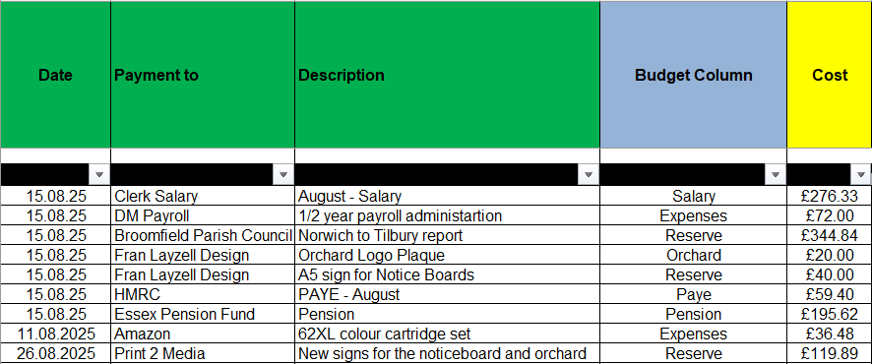

Total for approval £1164.56

2025/915 Review of the Bi-monthly bank reconciliation

2025/916 Note the Internal Auditor reports on the FY 2024 / 2025.
- For Fidelity Insurance Cover, the recommended guideline is the year end balances +50% of the precept. The Council needs to check that amount of its fidelity insurance to make certain that it is not under insured. (currently level of fidelity insurance is £25,000)
  - Year End Balance - £45,823
  - Precept £7,000
- The Council needs to review the composition of the Terms of Reference for the Orchard committee.

2025/917 Parish Council Budget Meeting for FY 2026-2027.
date to agree next year’s budget and set Precept.

REPORTS AND UPDATES

2025/918 Discuss and adopt the Biodiversity Policy 2025.

2025/919 Update on Local Government Reorganisation.

2025/920 Updates from Chelmsford Association of Local Councils.

2025/921 Representatives’ Reports: to discuss and debate any items.
- Little Hollows / Copperfield Place Liaison - Cllr Elwick
- Update on Copperfield Place landscaping work and road signage.

- Playing Field - Cllr Elwick and Cllr Towns
  - car park.
  - Consider a proposal to construct a Pétanque court adjacent to the car park.

- Community Engagement - Cllr Nelson and Cllr Stainton
  - Update on support for clubs and groups to update their information on the parish council website: www.chignal-pc.gov.uk

- Community Safety – Cllr Lewis
  - Defibrillator training from CHT

- Highways (include Hedges) - Cllr Towns, Cllr Elwick, Cllr Ballard
  - Update re a No through Road sign on hollow lane.

- Countryside conservation. – Cllr Lewis, Cllr Ballard.
Nature notes on the Parish website. Update on the wildlife survey.

2025/922 Items for the next Agenda:

Next meetings:
Monday 10th November 2025 Bi-Monthly Meeting.
Monday 12th January 2026 Bi-Monthly Meeting.
Monday 9th March 2026 Bi-Monthly Meeting and Annual Parish Meeting.
Monday 11th May 2026 Annual General Meeting and Bi-Monthly Meeting.

